

A COMPARATIVE STUDY REPORT
Comparative Study of Low-Code Development
versus Traditional Application Development Approaches
Understanding two different ways to build software — explained with diagrams, comparisons and real-life examples
Roll No. | 241401038
Department | Computer Science and Business Systems
Subject | Low-Code Application Development using Zoho Creator
Topic | Comparative Study of Low-Code Development versus Traditional Application Development Approaches

Table of Contents
1. Introduction
2. Traditional Software Development
3. Low-Code Software Development
4. Detailed Comparison Table
5. Advantages & Disadvantages of Both Approaches
6. Real-Life Examples
7. Case Study — Employee Leave Management System
8. When Should You Choose Which Approach?
9. Beginner Interview Questions & Answers
10. Summary
11. Conclusion
12. References

1. Introduction

What is Software?
Software is a set of instructions that tells a computer, phone, or any digital device what to do. Every app you open — a game, a calculator, a chat app — is software. Without software, computer hardware (screen, chip, memory) cannot do anything useful on its own.

What is Software Development?
Software development is the process of planning, building, testing, and maintaining these sets of instructions. It is how an idea in someone's head becomes a working app that people can actually use on their phone or computer.

Why is Software Important Today?
Software touches almost every part of daily life. We use it to talk to friends, pay bills, book tickets, learn new skills, and even monitor our health. Businesses, schools, hospitals, and governments all depend on software to work efficiently and serve people faster.

Why Do Businesses Need Software?
Businesses use software to save time, reduce human error, reach more customers, and manage information safely. A business without good software today is like a shop without doors — customers simply cannot reach it easily.
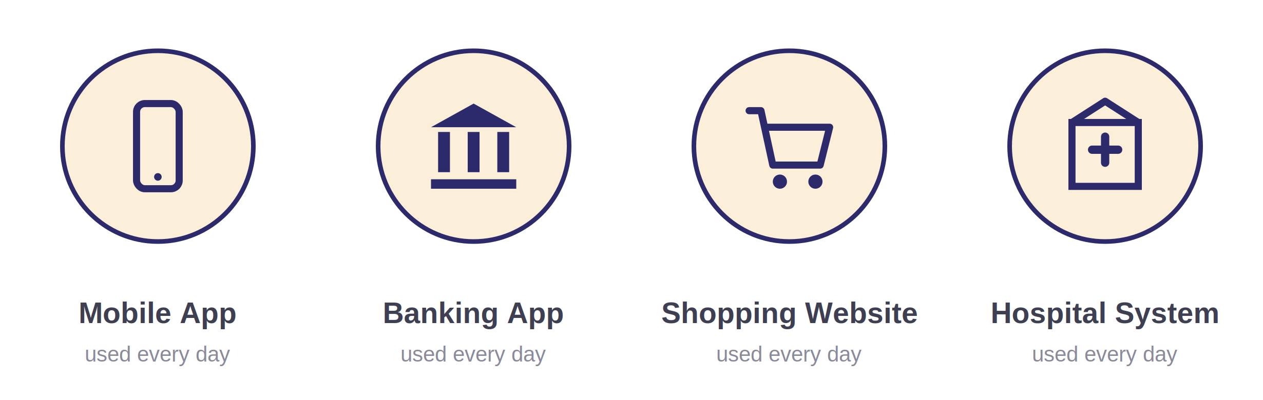
Figure 1: Software is everywhere — from mobile apps and banking systems to online shopping and hospital record systems, people rely on software every single day.
💡 Quick Fact
By the time you finish reading this document, millions of people around the world will have opened a banking app, a shopping app, or a hospital app — all powered by software.

2. Traditional Software Development

Definition
Traditional software development is the classic way of building software. A team of programmers writes every line of code by hand, using programming languages such as Java, Python, or C++. Nothing is pre-built — everything is created from scratch, exactly the way the project requires.

The Process
This approach follows a clear, step-by-step process, often called the Software Development Life Cycle (SDLC). Each stage must be completed carefully before moving to the next one.
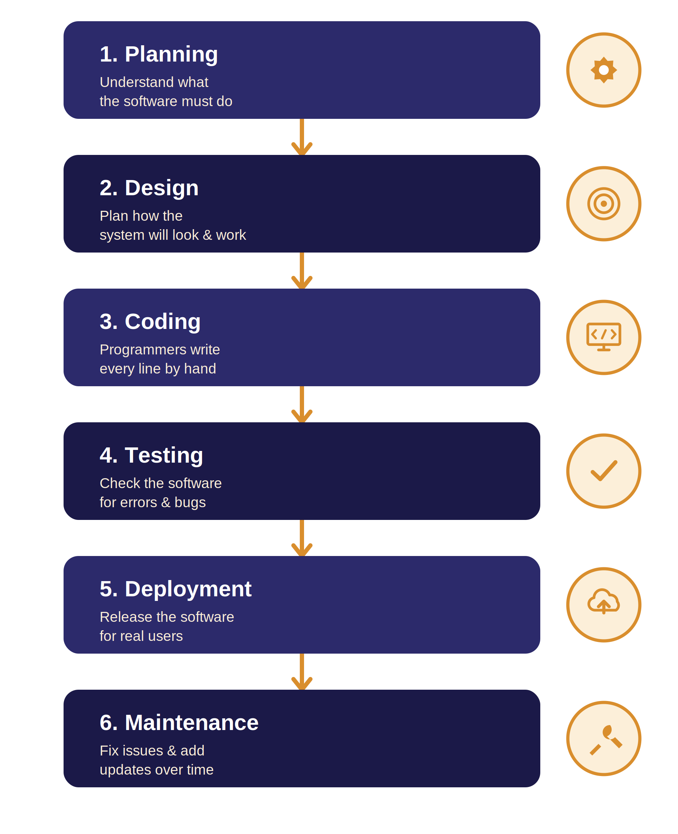
Figure 2: The Traditional Software Development Life Cycle (SDLC) — six stages that a project moves through, one after another.
- Planning: The team figures out exactly what problem the software needs to solve.
- Design: Engineers decide how the system will be structured and how it will look.
- Coding: Programmers write the actual code, line by line, using a programming language.
- Testing: The software is checked carefully to find and fix bugs before release.
- Deployment: The finished software is released so real users can start using it.
- Maintenance: The team keeps fixing issues and adding improvements after launch.

Programming Languages & Coding From Scratch
In traditional development, nothing is assumed or auto-generated. Every button, every calculation, and every screen is written using code. This gives full control over how the software behaves, but it also means development takes longer and needs skilled programmers.

3. Low-Code Software Development

Definition
Low-code software development is a modern way of building applications with very little hand-written code. Instead of typing thousands of lines of code, developers use a visual builder — a screen filled with ready-made blocks that can simply be dragged into place. Platforms like Zoho Creator, Mendix, and Appian work this way.

Visual Development & Drag-and-Drop
In a low-code platform, building an app feels more like arranging furniture in a room than writing an essay. You drag a button here, a text box there, and connect them together using simple, visual settings — no complex code required.

Reusable Components & Rapid Development
Low-code platforms come with reusable, ready-made components — buttons, forms, tables, and workflows — that have already been built and tested. This is why apps can be built much faster than the traditional way.
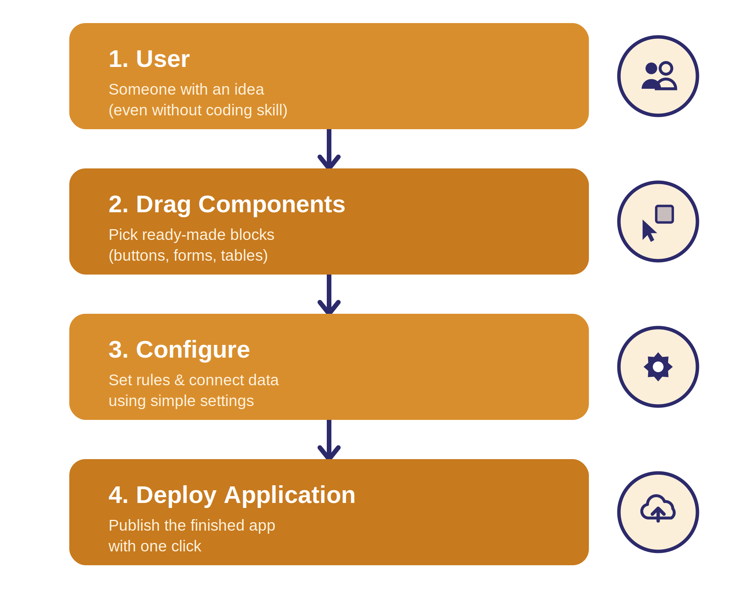
Figure 3: The Low-Code development flow — from a person with an idea to a fully deployed application, in just a few visual steps.

4. Detailed Comparison
The table below compares Traditional and Low-Code development across fifteen important factors, so you can quickly see how the two approaches differ.
# | Factor | Traditional Development | Low-Code Development
1 | Development Speed | Slow — takes weeks to months | Fast — apps built in days
2 | Coding Requirement | Heavy hand-written coding needed | Very little coding — mostly visual
3 | Learning Curve | Steep — needs real programming skill | Gentle — beginners can learn quickly
4 | Customization | Very high — anything can be built | Limited to what the platform allows
5 | Cost | Higher — needs a large skilled team | Lower — fewer people, less time
6 | Performance | Usually higher, fully optimised | Good, but not always fully optimised
7 | Security | Fully controlled by the dev team | Depends on the platform's security
8 | Scalability | Excellent for very large systems | Good, but can hit platform limits
9 | Maintenance | Needs an ongoing developer team | Mostly handled by the platform vendor
10 | Deployment Time | Longer — manual setup required | Very short — often one-click deploy
11 | Business Use | Complex, mission-critical systems | Everyday business apps & workflows
12 | Target Users | Professional programmers | Beginners, business users, citizen developers
13 | Flexibility | Extremely flexible, no limits | Flexible within platform boundaries
14 | Skill Requirement | Strong coding knowledge required | Basic computer literacy is often enough
15 | Time to Build | Months for a full application | Days to a few weeks for a full app

5. Advantages & Disadvantages

Advantages of Low-Code Development
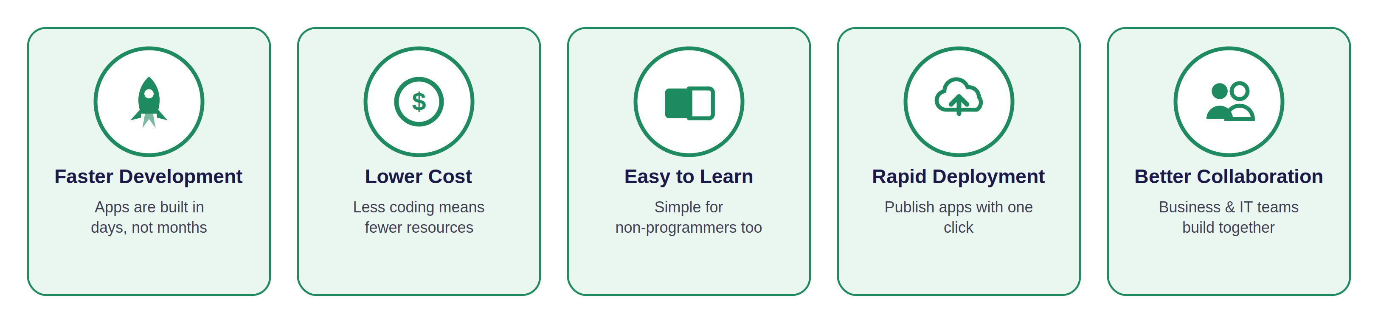
Figure 4: The five biggest benefits businesses get from choosing a low-code platform.

Disadvantages of Low-Code Development
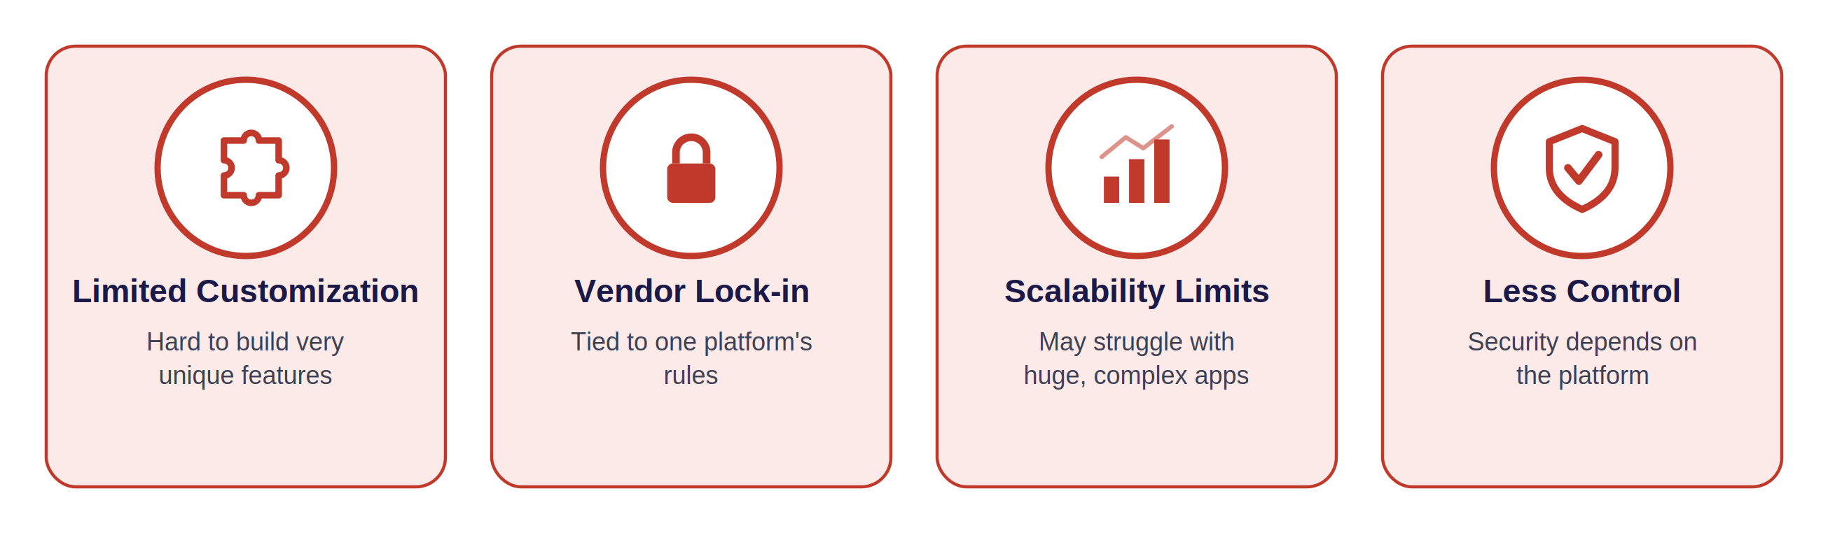
Figure 5: Low-code development also comes with some real limitations to keep in mind.

Advantages of Traditional Development
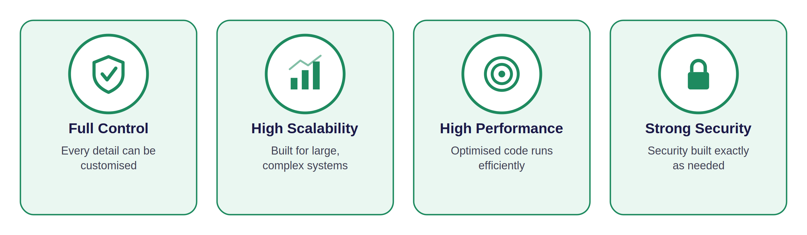
Figure 6: Traditional development remains the stronger choice for control, scale, and performance.

Disadvantages of Traditional Development
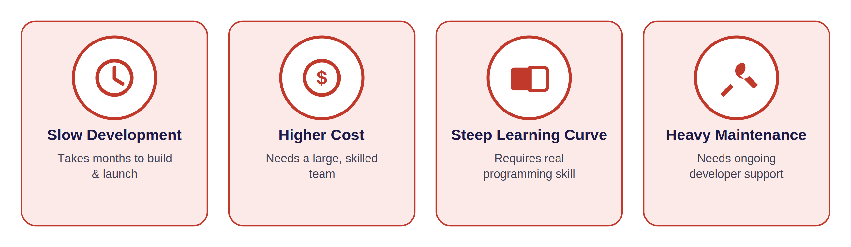
Figure 7: The trade-offs of building everything by hand, from scratch.

6. Real-Life Examples
Software development ideas can feel abstract, so here are three everyday comparisons that make the difference between Traditional and Low-Code development easy to picture.
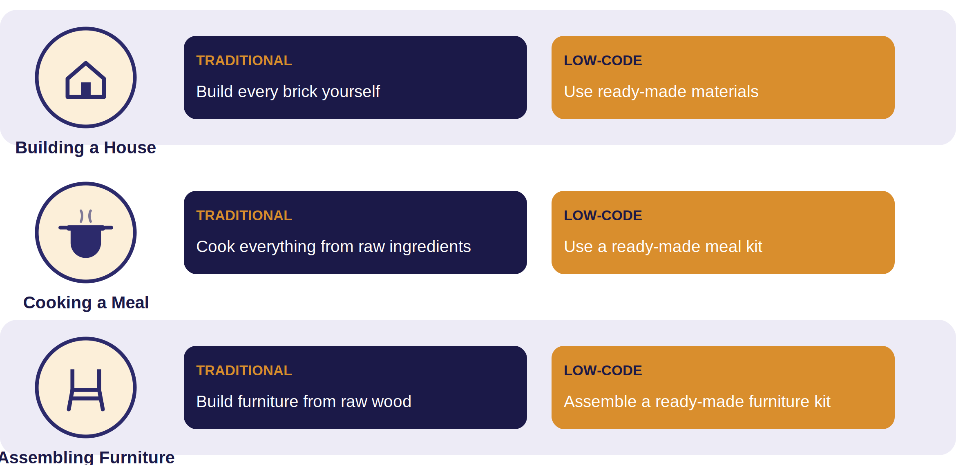
Figure 8: Three simple, everyday analogies — building a house, cooking a meal, and assembling furniture — showing the same 'from scratch vs ready-made' idea behind Traditional and Low-Code development.
🏠 Example 1 — Building a House
Traditional development is like building a house brick by brick, from the ground up. Low-code development is like using ready-made wall panels and pre-fitted materials — faster, but with fewer custom design choices.

7. Case Study

Employee Leave Management System
Company A wants to build a simple internal system where employees can apply for leave, and managers can approve or reject those requests. Let's compare how this project would look under each approach.
Factor | Traditional Development | Low-Code Development
Development Time | 10–12 weeks | 1–2 weeks
Budget | High — custom coding & testing | Low — mostly configuration
Team Size | 4–6 people (developers, testers, designer) | 1–2 people (a citizen developer)
Maintenance | Ongoing developer support required | Mostly handled by the platform
Deployment | Manual server setup & release process | One-click publish to the cloud

📌 Takeaway
For a simple internal tool like a Leave Management System, low-code development lets Company A launch in about two weeks with a tiny team — while traditional development would take months and a much larger budget. But if the company later needs deep, unique features tied to complex payroll systems, traditional development may be worth the extra time and cost.

8. When Should You Choose Which Approach?

When Should You Choose Low-Code?
- Startups: When a startup needs to launch a working product quickly to test an idea with real users.
- Schools: When a school wants a simple system for attendance, grading, or fee tracking without hiring a full development team.
- Small Businesses: When a small business needs an internal tool — like inventory tracking — fast and on a limited budget.

When Should You Choose Traditional Development?
- Banking: When the system must handle sensitive financial data with very strict, custom security rules.
- Healthcare: When patient data and hospital workflows need highly specialised, tightly controlled software.
- Large Enterprise: When a company needs a massive system that must scale to millions of users.
- E-commerce: When a shopping platform needs deep customisation for a unique shopping experience.
- Government: When systems must meet strict regulations, security standards, and long-term reliability needs.

9. Beginner Interview Questions & Answers
Q: What is software development?
A: It is the process of planning, building, testing, and maintaining computer programs or applications.
Q: What does 'low-code' mean?
A: It means building software using visual tools and drag-and-drop components, with very little hand-written code.
Q: Name one popular low-code platform.
A: Zoho Creator is one popular example; others include Mendix and Appian.
Q: What is the SDLC?
A: The Software Development Life Cycle — the standard stages a traditional software project goes through: planning, design, coding, testing, deployment, and maintenance.
Q: Which approach is usually faster to build with, and why?
A: Low-code development, because it uses ready-made components instead of writing code from scratch.
Q: Why might a bank avoid low-code platforms for its core systems?
A: Because banks often need very strict, custom security and compliance rules that a general-purpose platform may not fully support.

10. Summary
Traditional software development means writing every part of an application by hand, using programming languages, and following a structured step-by-step process. It gives complete control and is best for large, complex, and highly customised systems. Low-code development, on the other hand, uses visual, drag-and-drop tools to build applications quickly with very little coding, making it ideal for smaller, faster projects and for people who are new to programming.

11. Conclusion
Neither approach is 'better' in every situation — they simply serve different needs. If you need speed, low cost, and ease of use, low-code development is a great starting point, especially for beginners and small projects. If you need deep customisation, top performance, and full control over every detail, traditional software development remains the stronger choice. Understanding both approaches helps you choose the right tool for the right job — and that is one of the most valuable skills a software engineer can have.

12. References
GeeksforGeeks — "Difference Between Low-Code Software Development and Traditional Software Development" (used only as a general conceptual reference).
📝 Note on Originality
This document is an original explanation written entirely in the author's own words, based on general, publicly available educational concepts about software development. No text has been copied from any source.

